on

**Restaurant Automation System (FooZito)**

*Submitted in partial fulfillment for the award of the degree*

Of

**BACHELOR OF TECHNOLOGY**

in

**SOFTWARE ENGINEERING**

By

**Pranika Jindal(RA1411020010137)**

**Shubhangi Narayan(RA1411020010144)**

**Pankhuri Verma(RA1411020010145)**

**Vishal Gupta(RA1411020010161)**

*Under the guidance of*

**Dr. J.S Femilda Josephin**

(Asst. Prof(Sr.G), Department of Software Engineering)



**FACULTY OF ENGINEERING AND TECHNOLOGY**

SRM Nagar,Kattankulathur-603 203

Kancheepuram Dist.

**April 2017**

**BONAFIDE CERTIFICATE**

Certified that this Minor Project report Title **“RESTAURANT AUTOMATION SYSTEM (FooZito)**” is the bonafide work of **Pranika Jindal(RA1411020010137), Shubhangi Narayan(RA1411020010144),Pankhuri Verma (RA1411020010145) and Vishal Gupta(RA1411020010161)** who carried out the project work under my supervision .Certified further, that too the best of my knowledge the work reported here in does not form part of any other project report or dissertation on the basis of which a degree or award was conferred on an earlier occasion of this or any other candidate.

Signature of the Guide Signature of the HOD

Dr J.S Femilda Josephin Dr C.Lakshmi

Asst.Professor(Sr.G) Professor & Head

SWE Department SWE Department

SRM University SRM University

**ACKNOWLEDGEMENT**

We take this opportunity to thank our Director (E&T), **Dr.C.MuthamizhChelvan,** for providing us with excellent infrastructure that is required for the development of our project.

We would also like to thank **Dr.C.Lakshmi,** Professor and Head of Department of Software Engineering, for providing us conductive ambience for developing our project.

We also convey our immense gratitude to **Mr S.Kartik,** Project Coordinator, Assistant Professor (Sr.G), Departmant of Software Engineering who gave us constant inspiration and suggestions throughout the project work.

We specially thank our project guide **Ms J.S Femilda Josephin,** Assistant Professor (Sr.G), Department of Software Engineering, who has been instructing us right from the initial stages of the project till the finishing days. Our guide provided us with all the knowledge, support and motivation to carry out this project with utmost dedication. We owe him for all the many opportunities catered to us to enlarge our prospective. We gratefully acknowledge his leadership and brilliant ideas throughout the project days.

We also convey our gratitude to all other members in the project panel and those who have contributed to this project directly or indirectly.

Last but not the least, we would like to thank our parents, friends and acquaintances for their constant help and constant support throughout the project.

Thank you all.

**INDEX**

1. PROBLEM DESCRIPTION 4
2. INTRODUCTION 5
3. DOMAIN STUDY 6
4. REQUIREMENTS

4.1 Requirements Elicitation 7

4.2 Requirements Analysis 8

4.3 Software Requirement Specification 9

5. ARCHITECTURAL VIEWS

5.1 Use Case View 16

5.2 Logical view

5.2.1 Class Diagram 17

5.2.2 State Diagram 18

5.3 Process View 19

5.4 Development View

5.4.1 Component Diagram 20

5.4.2 Package Diagram 21

* 1. Physical View 22

6.DISCUSSION 23

7.CONCLUSION 24

8.REFERENCES 24

**Restaurant Automation System**

**1.ABSTRACT**

The “FooZito” is a GPS-based web application which helps people to find the closest restaurants based on the user’s current position and other specification like price, restaurant type, dish and more. Restaurant owners can provide their restaurant information using the web-portal. This information will act as the bases for the search results displayed to the user. An administrator also uses the web-portal in order to administer the system and keep the information accurate. The administrator can, for instance, verify restaurant owners and manage user information.

Furthermore, the software needs both Internet and GPS connection to fetch and display results. All system information is maintained in a database, which is located on a web-server. The application also has the capability of representing both summary and detailed information about the restaurants. It will consist of the following modules:

1.Home page- This is the main browsing page for the customers where they can see various services provided to them. They can avail these services by doing the Registration. Further they can Login to their accounts and place their orders.

2.GPS Tracking- This is the next page which will appear after Login. Automatic location of the user will be tracked or user can even enter their location manually.

3.Menu Selection- After the location of the customer is tracked and the restaurant name is displayed ,automatically the restaurant menu is displayed . The customer can select the food items from the menu and Add them to the Cart.

4.The Cart- The selected food items by the user are displayed in the cart and here the total amount is calculated and a payment gateway is provide to the customer for the payment of the amount selected by them.

5. Payment- In this module a payment gateway is provided for secure payment transaction. The amount calculated in the cart is paid using this gateway. Secure Hashing Technique is used for making the payment module secure. Various Encryption Techniques are used in the algorithms

**2.INTRODUCTION**

In current formal dining environments, some form of physical static menu is utilized to convey the available food and beverage choices to customers. Said menus are generally paper based and hence impose restrictions on the textual real estate available and the ability a restaurateur has to update them. This document specifies the requirements for a restaurant paper menu and ordering replacement strategy to alleviate the problems associated with the current archaic method. Three related concepts are encompassed by the general scope of the Restaurant Menu and Ordering System. The first pertains to the replacement of paper-based menus using an electronic format, the second relates to a complementary electronic strategy for the front of house handling of a customer’s order and the third surrounds the process of transferring said electronic orders to the kitchen for preparation. It should be noted that while the suggested strategy incorporates the use of various hardware components, the primary focus of the presented SRS relates to the constituent software elements.

Many restaurants are still operated using pen and paper methods, with little or no automation. Once a customer is seated waiters tends to the customers by jotting down the orders onto a piece of carbon paper and delivers it to the kitchen for food preparation. When the order is complete the owners have to preserve that carbon paper for the billing process. This “old fashion” system works but yields a large amount of carry pads around to take orders and also preservation for bills.

Another issue is record maintenance. In the old system when everything is done by paper, the management is responsible to keep all information saved and organized, which is not at all an easy task. Everyday tabs are collected, data needs to be organized and the employees need to be paid. This requires a great deal of time and attention. Also in the case of large number of customers requirement of waiters increases. The customer has to wait long for the waiter to come and take the order.

So in order to eliminate this paper work and the man work , the concept of automation has been introduced. This system will allow the customer to do everything online whether it is ordering food or paying for food. No preservation of carbon papers will be required as the customer will have to pay online as soon as he add items to the cart and do checkout process.

**3.DOMAIN STUDY**

The topic for our Web Programming Project is 'Restaurant Automation Portal’. Restaurant automation means the use of restaurant management system to automate the major operations of a restaurant establishment. Our application will be used to order food online whenever a user enters a restaurant.GPS system is used to detect the restaurant and subsequently the menu of the restaurant is displayed. The user can login into the website and order their food. The payment can also be made online. This will reduce the work of the waiter and the restaurant will become automated to some extent.

## The “FooZito” is a GPS-based web application which helps people to find the closest restaurants based on the user’s current position and other specification like price, restaurant type, dish and more. Restaurant owners can provide their restaurant information using the web-portal. This information will act as the bases for the search results displayed to the user. An administrator also uses the web-portal in order to administer the system and keep the information accurate. The administrator can, for instance, verify restaurant owners and manage user information.

Furthermore, the software needs both Internet and GPS connection to fetch and display results. All system information is maintained in a database, which is located on a web-server. The application also has the capability of representing both summary and detailed information about the restaurants

**Literature Survey**

Foundation of Computer Science FCS, New York, USA. Volume 6– No. 7, January 2014 – www.ijais.org. 1. Chef Alerting System using Wireless Zigbee - This paper elucidates the concept and development of Zigbee technology which is IEEE standard 802.15.4 in dish ordering systems in hotels. This paper has shown the concept of an automatic self ordering system directly given to the chefs by the customer. The real time ordered data is send wirelessly using Zigbee technology. Chef can get the information simply on a display screen regarding dish name to be prepare and on which table it is ordered. IOSR Journal of Electronics and communication Engineering (IOSR-JECE) volume 2- www.iosrjournals.org Automatic Restaurant Ordering System using Zigbee - This paper provides a low-cost, convenient and easy to use system for automating order placement system for restaurants. Each table of restaurant has a menu display unit which is powered by microcontroller. The client will scroll menu list using keypad provided along with. Customer could order his food or drink just using this keypad. Each table will consist of a microcontroller based order placement unit. The unit shall have a keypad to browse through the menu.

**4. REQUIREMENTS**

**4.1 Requirement Elicitation**

For collecting the requirements of a system from users, customers and other stakeholders,we went to few of the restaurant owners :-

* Hoppipola
* Absolute Barbecue
* That Madras Place

And so after conducting this survey, the issues found were :-

* Payment issues on a regular basis.
* Requirement of large number of waiters

And their requirements were as follows :-

• Cost savings

• New business opportunities

• Time saving

• Allow for considerable profit

• Improvement of Customer relations.

**4.2 Requirement Analysis**

## There are 2 kinds of users for the proposed system.

## *Restaurant owners:*

The restaurant owners register themselves on the web application and add their menu. As any customer enters their restaurant the menu will display automatically. So this removes the requirement of waiters in their restaurant because the menu automatically came and the food can be ordered online now.

## 

## *End Users/Customers:*

## The end user will be the one who uses the app and will look at the menu and order the food without the need of the waiter.

The restaurant automation app permits to havesecure registration of customers and restaurant owners and provides a secure solution to order food online as well as offline, hassle-free checkout of items and instant billing process.

A customer can register with their personal details and either add preferred resturant location or allow gps to get their location so that they can get the menu of that place.

The customer can click the checkbox of the item in menu of any product they want to order, add the quantity of each item, add it to cart and then finalize their cart items at the end of shopping. They can then pay the final amount and order will be served at their table, reducing the hassle of waiting for the waiter to take the order.

The information about the time when customer has log in till the successful payment completion is stored in the app .

* 1. **Software Requirement Specification**

Table of Contents ii

1. Introduction 10

1.1 Purpose 10

1.2 Document Conventions 10

1.3 Intended Audience and Reading Suggestions 10

1.4 Product Scope 10

2. Overall Description 11

2.1 Product Perspective 11

2.2 Product Functions 11

2.3 User Classes and Characteristics 11

2.4 Design and Implementation Constraints 12

2.5 Assumptions and Dependencies 12

3. External Interface Requirements 12

3.1 User Interfaces 13

3.2 Hardware Interfaces 13

3.3 Software Interfaces 13

3.4 Communications Interfaces 13

4. System Features 13

4.1 System Feature 1 14

4.2 System Feature 2 14

4.3 System Feature 3 14

5. Other Nonfunctional Requirements 15

5.1 Performance Requirements 15

5.3 Security Requirements 15

5.4 Software Quality Attributes 15

**1.Introduction**

This section gives a scope description and overview of everything included in this SRS document. Also, the purpose for this document is described and a list of abbreviations and definitions is provided.

## 1.1 Purpose

The purpose of this SRS is to define the overall functionality of our project. It specifies all the requirement parameters needed to implement our project. The purpose of this document is to give a detailed description of the requirements for the “Foozito” website. It will illustrate the purpose and complete declaration for the development of system. It will also explain system constraints, interface and interactions with other external applications. This document is primarily intended to be proposed to a customer for its approval and a reference for developing the first version of the system for the development team.

## 1.2 Intended Audience and Reading Suggestions

**1.2.1**This Software Requirements document is intended for:

Developers who can review project’s capabilities and more easily understand where their efforts should be targeted to improve or add more features to it .

Project testers can use this document as a base for their testing strategy as some bugs are easier to find using a requirements document. This way testing becomes more methodically organized.

End users of this application who wish to read about what this project can do.

**1.2.2** The sequence for reading this document would be by beginning with the Overview then followed by Overall Description, External Interface Requirements, System Features and Other Nonfunctional Requirements.

## 1.3 Product Scope

In current formal dining environments, some form of physical static menu is utilized to convey the available food and beverage choices to customers. Said menus are generally paper based and hence impose restrictions on the textual real estate available and the ability a restaurateur has to update them. This document specifies the requirements for a restaurant paper menu and ordering replacement strategy to alleviate the problems associated with the current archaic method. Three related concepts are encompassed by the general scope of the Restaurant Menu and Ordering System. The first pertains to the replacement of paper-based menus using an electronic format, the second relates to a complementary electronic strategy for the front of house handling of a customer’s order and the third surrounds the process of transferring said electronic orders to the kitchen for preparation. It should be noted that while the suggested strategy incorporates the use of various hardware components, the primary focus of the presented SRS relates to the constituent software elements.

The “FooZito” is a GPS-based web application which helps people to find the closest restaurants based on the user’s current position and other specification like price, restaurant type, dish and more.

Restaurant owners can provide their restaurant information using the web-portal. This information will act as the bases for the search results displayed to the user. An administrator also uses the web-portal in order to administer the system and keep the information accurate. The administrator can, for instance, verify restaurant owners and manage user information.

Furthermore, the software needs both Internet and GPS connection to fetch and display results. All system information is maintained in a database, which is located on a web-server. The application also has the capability of representing both summary and detailed information about the restaurants.

**2. Overall Description**

This section will give an overview of the whole system. The system will be explained in its context to show how the system interacts with other systems and introduce the basic functionality of it. It will also describe what type of stakeholders that will use the system and what functionality is available for each type. At last, the constraints and assumptions for the system will be presented.

## 2.1 Product Perspective

This system will consist of two parts: one web application and one web portal. The web application will be used to find restaurants and view information about them while the web portal will be used for managing the information about the restaurants and the system as a whole.

The web application will need to communicate to a GPS application. The GPS will provide the web application with locations of both the user and the restaurants and the distance between them, but it will also provide maps and the functionality to display the application’s data on the map. The functionality provided by the GPS will be embedded into the application in order for the user to be able to use the functions in the application in a seamlessly manner.

Since this is a data-centric product it will need somewhere to store the data. For that, a database will be used. Both the web application and web portal will communicate with the database, however in slightly different ways. The web application will only use the database to get data while the web portal will also add and modify data. All of the database communication will go over the Internet.

## 2.2 Product functions

With the web application, the users will be able to search for restaurants. The result will be based on the criteria the user inputs. There are several search criteria and it will be possible for the administrator of the system to manage the options for those criteria that have that.

The result of the search will be viewed either in a list view or in a map view, depending on what criteria included in the search. The list view will have one list item for each restaurant matching the search criteria and show a small part of the restaurant information so the user can identify the restaurant. In both views the users will be able to either select a restaurant as target destination or get information how to get there, or view the information of a specific restaurant.

## 2.3 User Classes and Characteristics

There are three types of users that interact with the system: users of the web application, restaurant owners and administrators. Each of these three types of users has different use of the system so each of them has their own requirements.

The web application users can only use the application to find a restaurant. This means that the user have to be able to search for restaurants, choose a restaurant from that search and then navigate to it. In order for the users to get a relevant search result there are multiple criteria the users can specify and all results matches all of those.

The restaurant owners will not use the web application but the web portal instead. There they will manage the information about their restaurant, for example a description of the restaurant, contact information and their menu.

The administrators also only interact with the web portal. They are managing the overall system so there is no incorrect information within it. The administrator can manage the information for each restaurant as well as the options for both the web application users and the restaurant owners.

## 2.4 Design and Implementation Constraints

The web application is constrained by the system interface to the GPS navigation system . Since there are multiple system and multiple GPS manufacturers, the interface will most likely not be the same for every one of them. Also, there may be a difference between what navigation features each of them provide.

The Internet connection is also a constraint for the application. Since the application fetches data from the database over the Internet, it is crucial that there is an Internet connection for the application to function.

## 2.5 Assumptions and Dependencies

One assumption about the product is that it will always be used on computers and laptops that have enough performance. If the device does not have enough hardware resources available for the application, for example the users might have allocated them with other applications; there may be scenarios where the application does not work as intended or even at all.

Another assumption is that the GPS components in all devices work in the same way. If the device has different interfaces to the GPS, the application need to be specifically adjusted to each interface and that would mean the integration with the GPS would have different requirements than what is stated in this specification.

# **3.External Interface Requirements**

This section contains all of the functional and quality requirements of the system. It gives a detailed description of the system and all its features.

## 3.1 User Interfaces

A first-time user of the web application should see the log-in page when he/she opens the application. If the user has not registered, he/she should be able to do that on the log-in page.

If the user is not a first-time user, he/she should be able to see the search page directly when the application is opened. Here the user chooses the type of search he/she wants to conduct.

Every user should have a profile page where they can edit their e-mail address, phone number and password,.

When a user searches by price, this view should be the default one. The sorting header allows the user to sort the results according to price, restaurant name, distance, restaurant type and specific dish. Each result item includes information about the restaurants, a link to the restaurant’s web-page and an information link, which provides a more detailed description of the restaurant. There is also a filtering option, where the user can choose to filter the results by increasing or decreasing the price or distance range.

The restaurant owners and administrators interact with the system through a web-portal. A restaurant owner should be able to register on the web-portal in order to log in and manage the restaurant information. An administrator should also be able to log in to the web-portal where he/she can administer the system by for instance editing restaurant or user information.

**3.2 Hardware interfaces**

Since neither the web application nor the web portal have any designated hardware, it does not have any direct hardware interfaces. The physical GPS is managed by the GPS application in the device and the hardware connection to the database server is managed by the underlying operating system on the device and the web server.

## 3.3 Software interfaces

The web application communicates with the GPS application in order to get geographical information about where the user is located and the visual representation of it, and with the database in order to get the information about the restaurants. The communication between the database and the web portal consists of operation concerning both reading and modifying the data, while the communication between the database and the web application consists of only reading operations.

# **3.4 Communications interfaces**

# The communication between the different parts of the system is important since they depend on each other. However, in what way the communication is achieved is not important for the system and is therefore handled by the underlying operating systems for both the web application and the web portal.

# **4.System Features**

# **System Feature 1- The User**

4.1.1 Functional Requirements

TITLE: User registration - web application

DESC: Given that a user should be able to register through the web application. The user must provide user-name, password and e-mail address. The user can choose to provide a regularly used phone number.

4.1.2 Functional Requirements

TITLE: User log-in - web application

DESC: Given that a user has registered, then the user should be able to log in to the web application.

4.1.3 Functional Requirements

TITLE: web application - Search

DESC: Given that a user is logged in to the application, then the first page that is shown should be the search page. The user should be able to search for a restaurant, according to several search options. The search options are Price, Destination, Restaurant type and Specific dish. There should also be a free-text search option. A user should be able to select multiple search options in one search.

4.1.4 Functional Requirements

TITLE: web application - Search result in a map view

DESC: Search results can be viewed on a map. On the map, the relevant and closest restaurants according to the user’s position are shown.

4.1.5 Functional Requirements

TITLE: web application - Selecting the information link

DESC: A user should be able to select the information link, which is included on all result items. The link will direct the user to an information page, which includes a picture of the restaurant, the restaurant name, address, phone number, e-mail address, type of food, average price, restaurant description and a menu with name, description and price of the different dishes.

## System Feature 2- Restaurant Owner

4.2.1 Functional Requirements

Create an account

Restaurant owner log-in

Manage information

## System Feature 3- Administrator

4.3.1 Functional Requirements

Administrator log in

Verify restaurant owner

Manage restaurant types

Manage restaurant dishes

Manage restaurant information

Manage users

Manage restaurant owners

**5.Other Non-functional Requirements**

## Performance Requirements

The system will provide a real-time management of the cart session. The system requires minimum data to retrieve information and provide fast processing for animation.

## Safety Requirements

For possible loss, damage, or harm that could result from the use of the product few safeguards or actions must be taken, such as, backup of the program is highly recommendable. Refer to any external policies or regulations that state safety issues.

## Security Requirements

Regarding security or privacy issues surrounding use of the product or protection of the data used or created by the product. User are requested not to share their login and password.

## Software Quality Attributes

Some quality characteristics of the product are adaptability, availability, correctness, flexibility, interoperability, maintainability, portability, reliability, reusability, robustness, testability, and usability.

## Business Rules

It is intended to develop and grow the skills, knowledge, confidence, and

cultural understanding of the mentee. Hence increases customer service and retention.

# **Other Requirements**

* 24X7 availability of server systems.
* Back up facilities should be provided with enough space.
* Provide the session maintaining capabilities.
* The server has to provide good performance during peak hours.

**5.ARCHITECTURL VIEWS**

**5.1 Use Case View :**

The purpose of use case diagram is to capture the dynamic aspect of system. But this definition is too generic to define the purpose.

Coming to the use case we have primary and secondary actors. The primary actors are waiter, client and cashier and the secondary actor is chef. The user enters the restaurant and checks the menu and order the food online. The receipt is taken to the chef and the food is prepared. The cashier is the one who assures that the payment is done. He does not have to collect the cash but has to verify the online payments made by the customers. So the use case defines the generic view of the system.

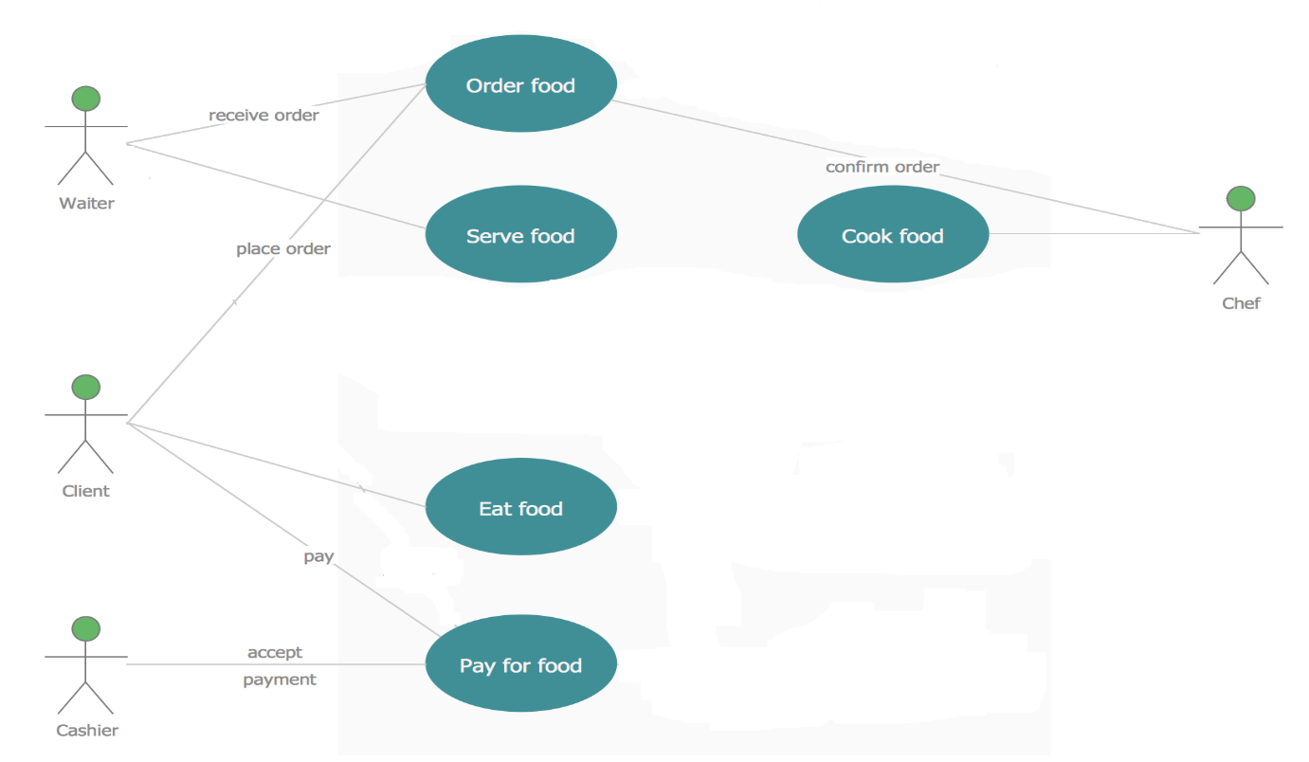

**5.2 Logical View**

**5.2.1 Class diagram**

The class diagram is the static diagram that represents the static view of application. Class diagram is not only used for visualizing, describing and documenting aspects of system

The class diagram consists of the classes like menu, restaurant, menu item, order, customer and review. The restaurant can perform operations like serving food and verifying payments.The customer can perform operations like order food and make payments.The order class consists of attributes like order no, item etc.



**5.2.2 State diagram**

The name of the diagram itself clarifies the purpose of diagram and other details.

The diagram shows the state when the order is being created by the customer. Either the customer can add the items to the cart or can delete the existing items. Then the cart shows the confirmed items, if the items are confirmed the user continues for the payment module or else go back to the cart.

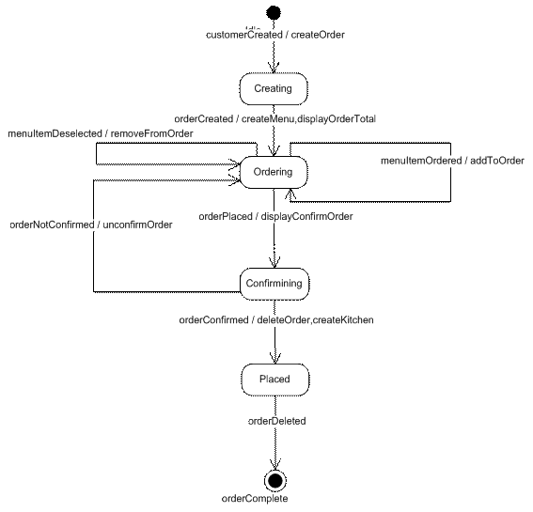

**5.3 Process View**

**Activity diagram**

The another important diagram in UML to describe dynamic aspects of the system. Activity Diagram is basically a flow chart to represent the flow of the activities.

The diagram shows as soon as the user login/register his GPS location is tracked and the menu is displayed of that particular restaurant. The user then selects the food items and add them to cart and proceed towards payment.

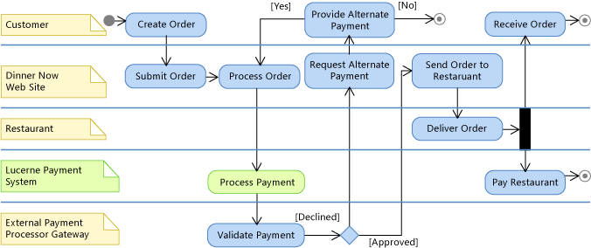

**5.4 Development View**

**5.4.1 Component diagram**

Component diagram visualize the various components in a system and how all components will work together.

In the diagram there is a terminal window in which user login or register. There is and inventory updation module in which owners and add their menu and which will reflect in the reports.All of these components are connected to a database. The transaction modules is responsible for conducting transactions securely.

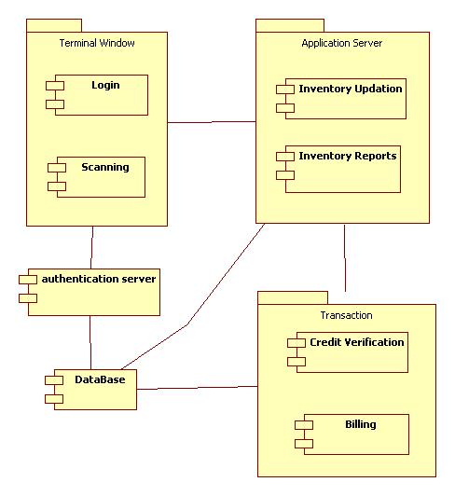

* 1. **Physical View**

* + 1. **Deployment Diagram**

Deployment diagram represents the deployment view of a system. It is related to the component diagram. Because the components are deployed using the deployment diagrams. A deployment diagram consists of nodes. Nodes are nothing but physical hardware used to deploy the application. We have a database server which consists of application server and web server and the web server is connected to various modules or called as clients

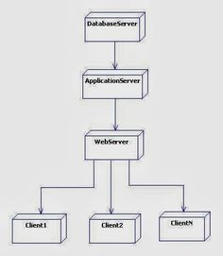

**6.DISCUSSION**

The goals that were set are as follows:

* 1. Implementation
  2. Testing
  3. User survey
  4. Completion of prototype
  5. User feedback
  6. Comparison with already existing similar systems
  7. Integration of all 4 modules
  8. Final implementation
  9. Quality attributes analysis

Memory allocated to the active connections was able to serve the system well when needed without any glitches and interruption. The ease of access and user friendly UI is indeed the most needed and accountable part of any online system which has an interface that directly takes user’s inputs. It is a web application to order food online as well offline and display the menu as soon as the user enters any restaurant. It lets the user to either enter the location manually or allow the GPS to track their location. Only the menus of the registered restaurants will be displayed.

All this was properly packaged for portability of the system from one server to another.

Along with the minor changes that were made, all major modules were checked for the availability of the current resource exhaustion and extra supplemental resources were added for the time of any crisis. The final deliverables and modules are:

* Login/Signup
* GPS tracker
* Menu of registered restaurants
* Add to Cart
* Payment gateway

**7.CONCLUSION**

Automated Restaurant Management System will work as a link between man power to provide optimum quick and effective and almost effortless services to the customer. It is a system which will not only reduce man power required but also increases the level of customer satisfaction . It is cost effective as it involves one time investment. The maintenance cost will be considerably low as compared to the salary of the waiters. Automated Restaurant Management System will revolutionize the hotel industry

**8.REFERENCE**

* Automated Restaurant Management System by Aman Jain1, Snehal Chauhan2, Anish Hirlekar3, Suraj Sarange4
* Touch Panel Based Restaurant Automation System using Zigbee by Prof. V. V. Joshi1, Uttej U. Badawane2, Md. Faisal Ahmed3, Nadim S. Shaikh4
* E-Restaurant: Online Restaurant Management System for Android by Mr. Maderla Rajesh, Mrs. Prof. G.Satya Prabha, Mr. P.V.Vara Prasad Rao